**Prod**

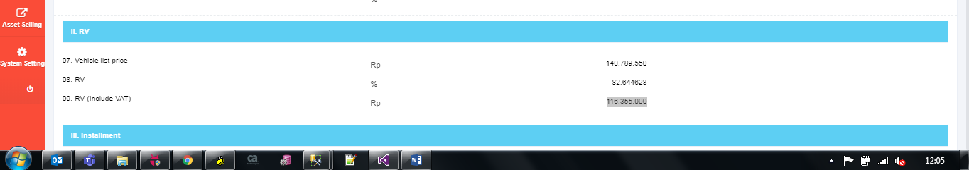

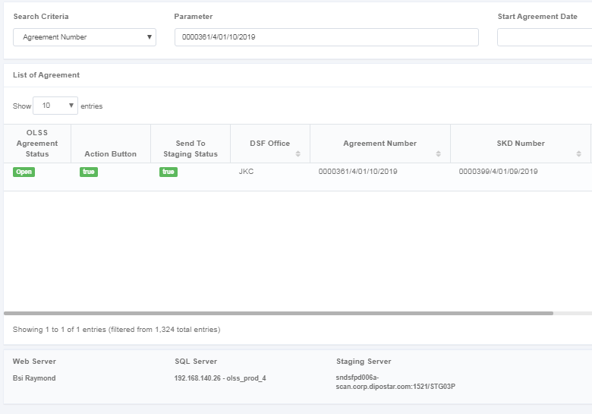

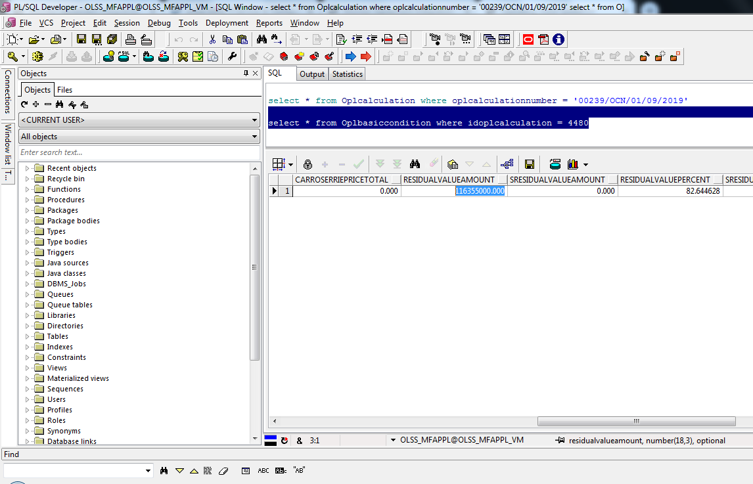

**QA ( Sebelum Test Sync )**

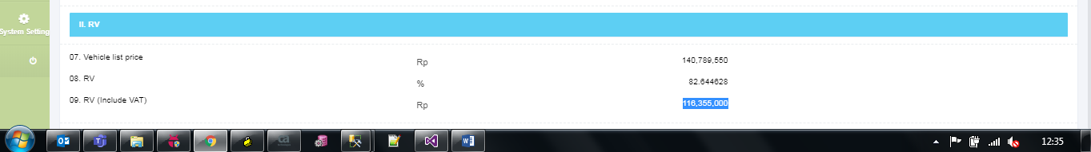

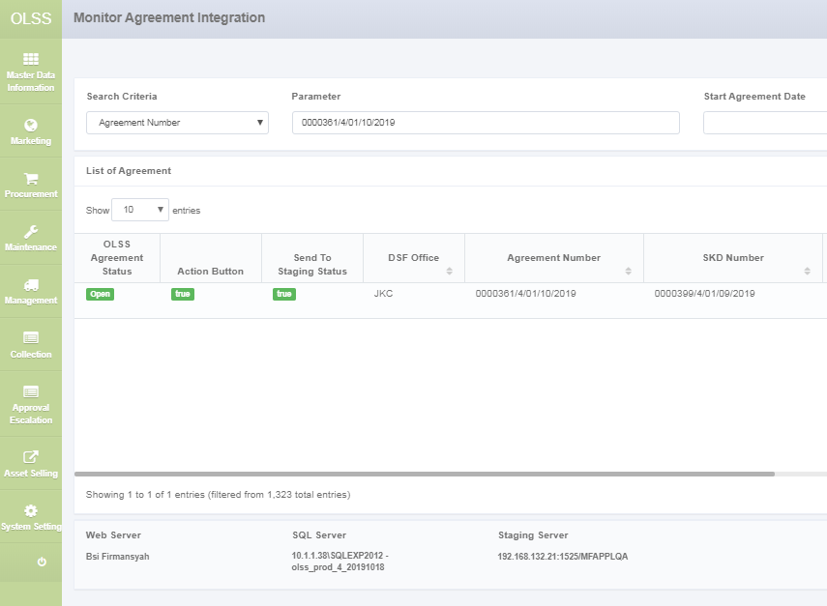

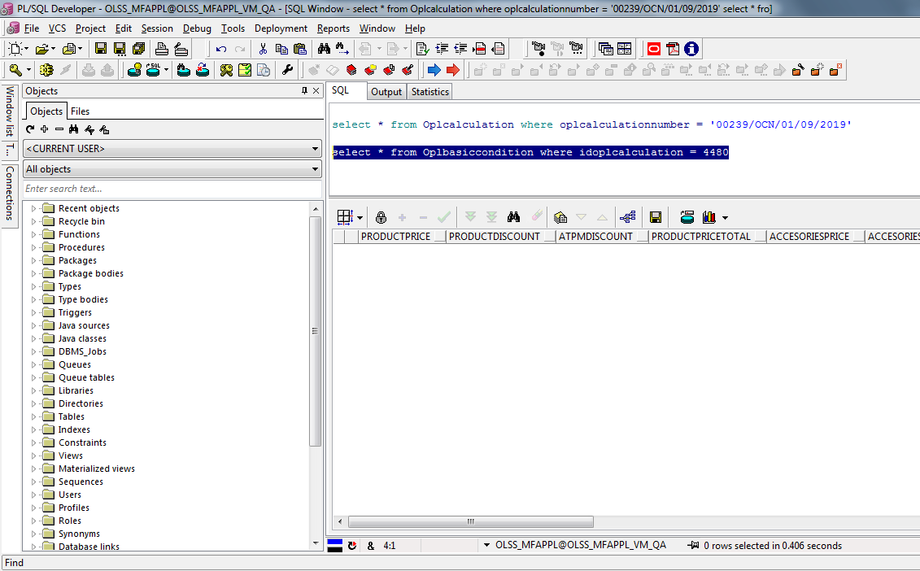

**Step For Test ( QA RV Sebelum VAT )**

Update agreement, set SendToStaging = 0

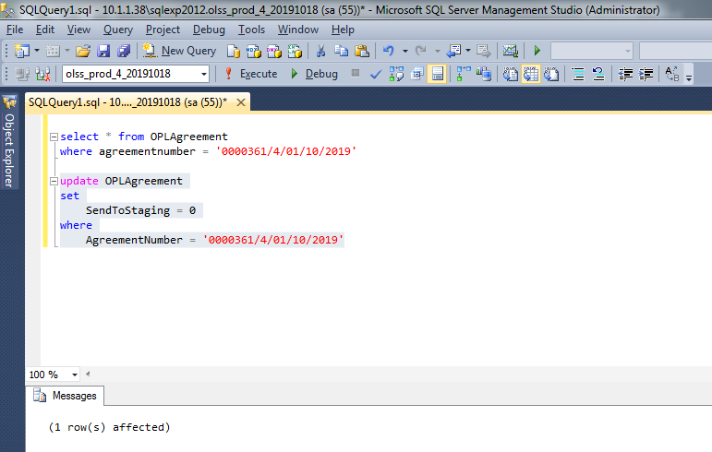

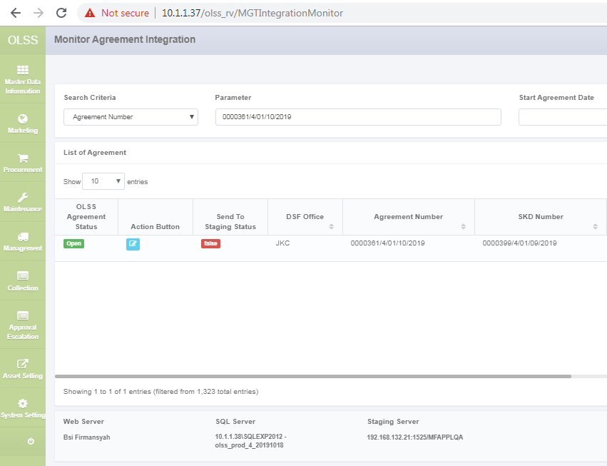

Klik Action Field Button

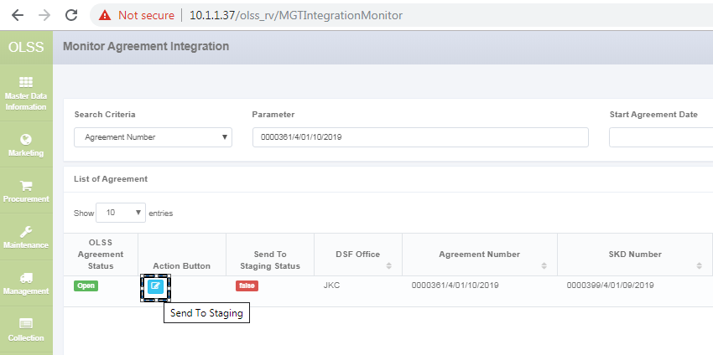

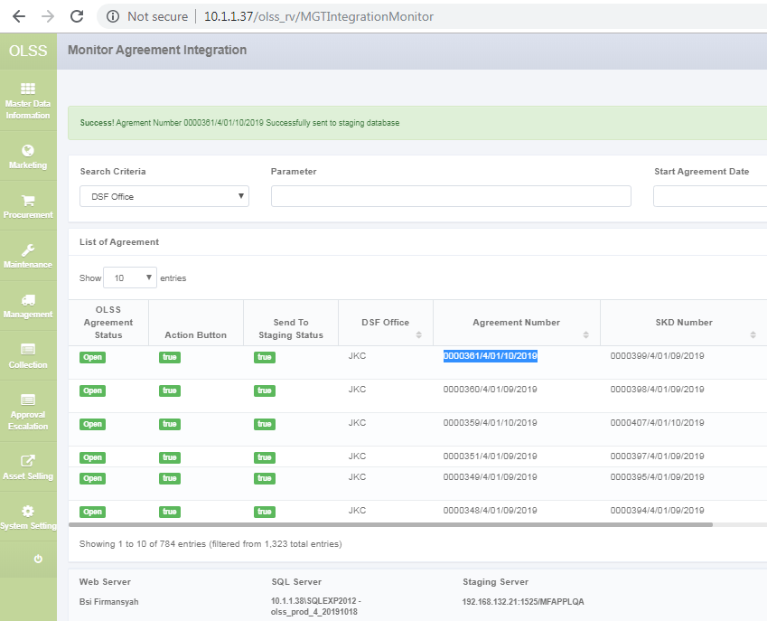

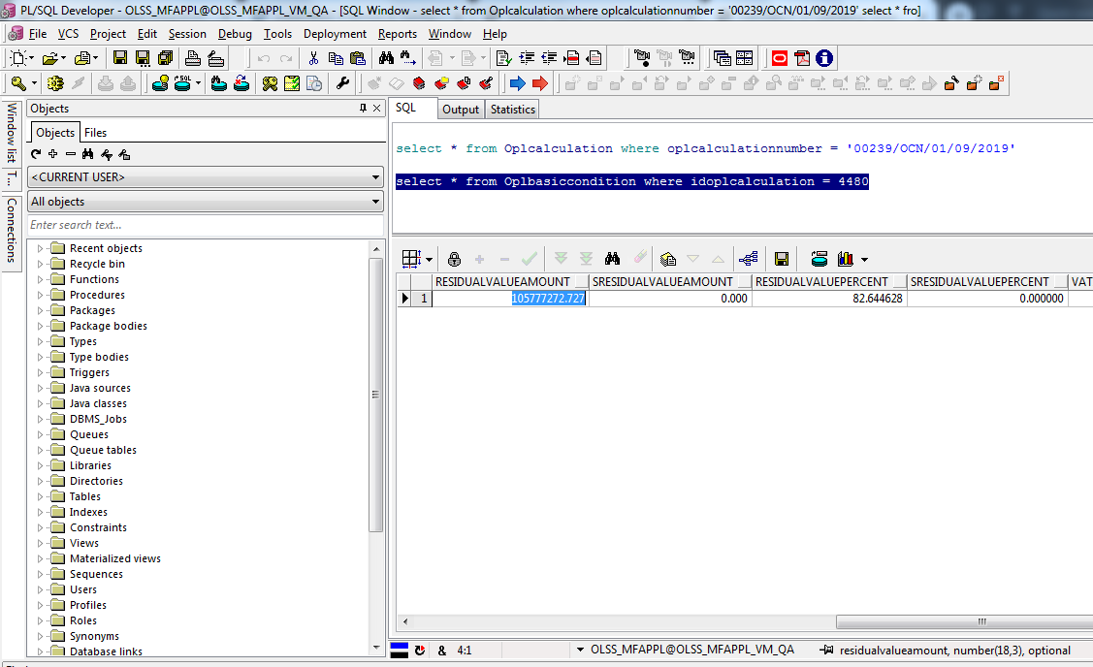

Rumusnya Sbb :   
ambil data dari DB OLSS.  
**Oplbasiccondition.ResidualValueAmount * 100/110 ( sebelum VAT )**

**Oplbasiccondition.ResidualValueAmount ( udah VAT )**